Simulating Land Surface Hydrology in LSM
——Review on documented methodologies and suggestion of improvement

Abstract
Land surface hydrologic processes are important components in current land surface modeling (LSM). They are complicated for simulation partly due to the temporal and spatial multi-dimensional coupling of two surface water reservoirs and two runoff procedures (WRRS), which are specified in this review. The main purpose of this paper is to evaluate recent progress in several literatures of strengthening the LSM’s capability in numerically representing above WRRS. Five components in WRRS serving as main impediments for quantifying land surface hydrology are analyzed and the modifications of LSM in each literature in terms of overcoming these impediments are assessed, with detail investigation of their hypothesis, intellectual merits, theoretical and practical limitations, etc. Finally the suggestion of improving Community Land Model (CLM) is given based on the literature review.

1. Introduction
The land surface modeling (LSM) is a virtual approach to understand and quantify the complex interaction between land surface system and overlying atmosphere system. A large number of physical processes are involved and simulated in this model in order to systematically represent the interplay of these sub-systems and incorporate the feedbacks within a unified context at common spatial and temporal platform. Vegetation, surface resistance and snow schemes are among the first group of physical subjects that were coupled into LSMs for the purpose of calculating dynamics of momentum, heat, and water flux. Later on substantial improvements were achieved toward this goal through incorporating subsurface hydrology, soil water drainage, evapotranspiration and large scale river routing, etc (Maxwell & Miller, 2005). These hydrology based implementations made the LSMs much more realistic in terms of reconstructing the water circulation in 3-D land surface environment.
However there are still some critical deficiencies remaining in simulating land surface hydrology for LSMs. Here we specify the investigation of land surface hydrology in this paper as in two water reservoirs and two runoff systems (for simplification we refer it as WRRS). They comprise soil water reservoir (unsaturated zone) and groundwater reservoir (saturated zone); surface runoff system and groundwater runoff system. The representation of these components in land surface hydrology are not fully accomplished in LSMs, causing it to become a challenging but hot area in LSM research. The scientific community are obtaining continuous progresses in this field based on overcoming the difficulties and problems associated with those components.
In this review we would firstly discuss the properties and simulation difficulties of WRRS within context of LSM, followed by comprehensive assessment on recent effort of improving LSM in enhancing the ability of simulating WRRS, particularly focusing on four literatures and their proposed methodologies. Finally the suggestion about some further modification of hydrologic simulation in LSM is provided based on understanding and assimilation of previous work. The papers involved in this literature review include:
(1) Impact factors in land-atmosphere interactions: surface runoff generations and interactions between surface and groundwater, Xu Liang, Zhenghui Xie, Global and Planetary Change, 2003, vol.38; (Referred as paper of Liang & Xie)
(2) Groundwater influence on soil moisture and surface evaporation, Xi Chen, Qi Hu, Journal of Hydrology, 2004, vol. 297; ( Referred as paper of Chen & Hu)
(3) Representation of Water Table Dynamics in a Land Surface Scheme. Pat J.-F Yeh and Elfatih A. B. Eltahir, Part I: Model Development; Journal of Climate, Vol. 18,No12, Part II: Subgrid Variability, Journal of Climate, Vol. 18, No 12. (Referred as papers of Yeh & Eltahir)

2. Properties of WRRS and impediments in simulating them in LSM
The two land surface reservoirs, which include soil reservoir and groundwater reservoir, play an important role in energy and water reorganization during the land surface-atmosphere interaction process. They receive heat and water vapor flux from atmosphere, absorb these energy and mass based on their intrinsic pattern and then dissipate them back into atmosphere or river system. Figure 1 gives a brief illustration for this procedure. Spatially and temporally these two reservoirs are inherently coupled while they also have distinct hydrologic and thermodynamic features which need to be simulated respectively.
Infiltration
Surface Runoff
Recharge
Groundwater Runoff
Water Table Level
Soil Reservoir
Groundwater Reservoir

Figure 1 Schematic diagram representing WRRS components
All of above papers concentrates on how to improve the theoretical and numerical representation of these two reservoir and associated hydrological processes. Among this dynamic mechanism, there are five components acting as essential impediments to LSM simulation, which are extensively analyzed and effectively ameliorated in those papers. These five components are:
- Surface runoff;
- Surface infiltration;
- Soil reservoir recharge (or infiltration) to groundwater reservoir;
- The location of water table, i.e., the location of surface interface of groundwater reservoir;
- The runoff of groundwater reservoir, i.e., the groundwater discharge.

The paper of Liang & Xie utilizes several paragraphs to demonstrate the deficiency in LSM simulation due to the complexity of component (1)&(2)---surface runoff and surface infiltration. Two surface runoff generation mechanisms (infiltration excess runoff and saturation excess runoff) are highlighted in this paper and the suggestion is that the precise representation of these two runoff schemes is substantially important for large scale hydrologic simulation in LSMs. Some examples of insufficient description of these runoff procedures are discussed in their paper to illustrate that these kind of simulation would generate too much or too little runoff compared with the observed runoff.
Reasons of these surface runoff and infiltration based impediments for LSM are summarized in Liang & Xie’s paper. I think the most important factor is the spatial heterogeneity of land surface properties, like soil hydraulic features, topography, and the variability of precipitation. Traditional LSM treats the soil within a grid as homogeneous, resulting in that subgrid infiltration and surface runoff are homogenous. These assumptions have obvious limitation compared with reality. Though this problem can be partially resolved by using parameterized soil hydraulic properties, while more recent research indicate that the subgrid variability of soil properties and related infiltration and surface runoff processes need to be explicitly incorporated into LSM. However this incorporation seems not be able to accomplished by adding subgrid higher resolution cells alone, since that would cause large computational burden on LSM simulation.
Recharge to groundwater reservoir is another challenging for describing the hydrologic interaction between soil reservoir and groundwater reservoir. Traditional LSM use zero-recharge condition (no leakage assumption for soil reservoir) or approximate recharge as equal to the hydraulic conductivity (k) in magnitude, assuming that the hydraulic potential at the interface of water table is equal to the gravitational potential. These methods of dealing with groundwater recharge is insufficient especially when the deep layer of soil reservoir is very active in terms of capillary potential variation and the two reservoirs have strong flux interaction driven by the combination of gravitational force and capillary force.
Papers of Yeh & Eltahir conduct investigation in Illinois to quantify this water flux exchange between two reservoirs. Observational data based water balance analyses support that monthly and seasonal variation of groundwater recharge in Illinois (large scale) are significant, ranging from about 150mm/month as upper boundary to –50 mm/month as lower boundary. Here positive value means that water drain from soil reservoir to groundwater reservoir, and negative value means the opposite situation. In addition the accurate reconstructing of these flux depends on virtual description of hydrologic conditions (include capillary potential and conductivity) at the interface.
Location of groundwater table and groundwater reservoir discharge are intrinsically related and the representation of their variation in LSM need to be enhanced. The difficulty of estimating water table in LSM partly stems from that most LSMs confine their representation of soil reservoir in a certain number of layers, each with invariant thickness. And this configuration could not fully meet the requirement of simulating dynamic variation of water table, particularly when water table is far below the lowest layer in soil reservoir. Additionally, given the unique relationship between water table location and the groundwater runoff (which is typically described as “rating curve” in groundwater reservoir analysis), uncertainty in quantifying water table would be transferred to the simulation of groundwater discharge.
Starting from above analyses of the five components within WRRS and predicaments they put on LSM hydrologic simulation, we will investigate in details that
(1) How these papers (Liang & Xie, Chen & Hu, Yeh & Eltahir) modify the physical and numerical representation of above components, what kinds of hypotheses are used in their research;
(2) What advantages these modification achieved, to which extent the impediments are overcome;
(3) What are problems remaining in the methodologies proposed in their paper;
Beyond above evaluation we will also discuss the implication from these papers to the update of current National Center for Atmospheric Research (NCAR) Community Land Model (CLM)

3. Incorporate sub-grid soil heterogeneity to simulate surface runoff
The statistically based algorithm is proposed in Liang & Xie’s paper to simulate surface infiltration and infiltration excess runoff with the merit of quantitatively represent subgrid heterogeneity of soil property. In this paper the soil infiltration capability within a river basin is assumed to follow a predefined power law distribution function (see Figure 2), in which the parameters can be estimated from soil survey database and not related to model simulation status. The soil moisture capacity for the domain is assumed to follow a similar statistical distribution. These two hypotheses quantitatively incorporate the subgrid heterogeneity of soil properties without introducing too much computational complexity.
Within each small piece of surface area in plot of soil moisture capacity Vs. Fraction of studied area, the saturation excess runoff is hypothesized as homogeneous and can be calculated as function of stepwise precipitation, initial soil moisture content, and distribution parameters of basin subgrid soil moisture capacity, which include the shape parameter and maximum point soil moisture capacity. The integral of this saturation excess runoff along the area fraction will provide the total saturation excess runoff within this time step. After the saturation excess runoff is calculated, the infiltration excess runoff is derived following similar algorithm, and it is the function of previous calculated saturation excess runoff, stepwise total precipitation, potential infiltration rate’s distribution parameters.
The results are very sensitive to the distribution parameters which indicates that initial data investigation on these parameters are important to model simulation. An alternative approach is to define these soil properties as parameters in LSM and calibrate them with the runoff observation data. Some further research find that these distribution parameters, for example, the shape parameter, can vary from basin to basin in large extent. So the estimation of these parameters may be a potential impediment for applying this method in other large scale land surface hydrologic simulation.
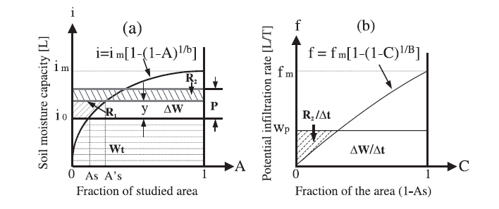

Figure 2 Distribution of soil moisture capacity and potential infiltration rate,
by Liang & Xie

4. Couple soil reservoir and groundwater reservoir in seamless approach
All of these papers design appropriate methods to dynamically portray the water table location, as well as calculate the water flux between two reservoirs at the interface. In Liang & Xie’s paper a moving boundary across soil layer and saturated aquifer layer is established based on physical implementation of Darcy Law. The flux at the boundary as water table is formulated using:
$(K(θ)−D(θ)\frac{∂θ}{∂z})|z=α(t)=Q_{b2}+E_{2}−n_{e}(t)\frac{dα}{\text{dt}}$ (1)
where $K(θ)$ is soil conductivity at water table, $α(t)$ is water table level at time t, Q and E are subsurface flow and transpiration from groundwater reservoir, respectively.
The characteristic function of transient variation of soil water content can be described based on one-dimensional Richards equation:
$\frac{∂θ}{∂t}=\frac{∂}{∂z}(D(θ)\frac{∂θ}{∂z})−\frac{∂K(θ)}{∂z}$ (2)
This is the governing equation of soil reservoir water movement. The vertical integral of equation (2) combined with surface boundary condition and lower boundary condition (Equation (1) will generate following expression of transient fluctuation of total water content in both soil reservoir and groundwater reservoir:
$\frac{d\overline{θ}}{\text{dt}}−(n_{e}(t)+θ_{s})\frac{dα}{\text{dt}}=P−R−Q_{b}−E_{t}$ (3)
The purpose of deriving Equation (3) is to calculate both water table level $α(t)$ and total soil moisture in soil reservoir $\overline{θ}(t)$ using finite element method and finite difference method and forward algorithm along with LSM. However the paper does not express this numerical method clearly in that the description of derivation of total moisture in soil zone is very sketchily and it seems not to be closely related with other variables in the same equation. The concept of “coefficient matrix” is also confusing.
However this algorithm has prominent merits regarding that it does not setup any specific assumptions in hydrologic properties of two reservoirs and can be applied into a broad band of situations. With respect to numerical implementation, the proposed method links the upper soil layer and lower groundwater reservoir seamlessly, achieving that the derived flux across the water table interface is not approximation but theoretical value.
The paper of Chen & Hu proposes an advanced scheme to represent the coupling of two water storage systems in the perspective of simulating recharge of groundwater from adjacent discretized soil layer using following formulation (see Figure 3 for details in soil layer configuration):
$d_{4}\frac{∂θ_{4}}{∂t}=D(\frac{∂θ}{∂z})_{3}−D(\frac{∂θ}{∂z})_{4}+K_{3}−K_{4}$ (4)
where $D(\frac{∂θ}{∂z})_{4}$ stands for the flux between lowest soil layer and groundwater reservoir which is calculated by soil moisture difference between two reservoirs, and the vertical distance between groundwater table and mid-point of the lowest layer; D is diffusivity term. The model in this paper treat groundwater table as an input parameter and validate the approximation of using monthly water table measurement as the input to the daily or finer temporal resolution of water table required in the hydrologic simulation. While the implementation of observed water table data is a weakness for this paper since most study area lack of ground survey data of groundwater table and model simulation generally define water table level as a intrinsic state variable.
Yeh & Eltahir’s paper utilizes a totally different but effective way to derive water table level within the proposed LSM numerical simulation. A simplified one dimensional non-linear reservoir model is used to describe dynamic relationship among groundwater recharge, groundwater discharge and water table level:
$S_{y}\frac{{\text{dZ}}_{w}}{\text{dt}}=I_{\text{gw}}−Q_{\text{gw}}$ (5)
where $S_{y}$ is aquifer specific yield, $Z_{w}$ is water table level, $I_{\text{gw}}$ and $Q_{\text{gw}}$ are groundwater recharge and discharge, respectively. The paper links groundwater recharge and water table level using a statistical method which is similar to that used in Liang & Xie’s paper of calculating infiltration and saturation excess runoff based on subgrid soil heterogeneity. Here the subgrid heterogeneity of water table level is considered and a two parameter gamma distribution function is predefined to characterize the spatial variability of water table. Under these reasonable assumptions, the Equation (5) is adapted as
$S_{y}\frac{\text{dE}(Z_{w})}{\text{dt}}=I_{\text{gw}}−Q[E(Z_{w})]$ (6)
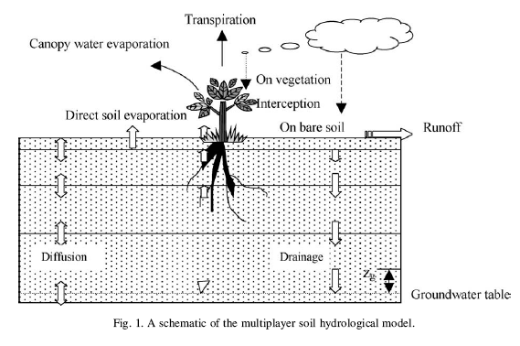

Figure 3. Soil layer configuration in Chen & Hu’s model, by Chen & Hu

in which $E(Z_{w})$ is the grid averaged water table level, and $Q[E(Z_{w})]$ is a analytical function bridging the grid averaged water table level and grid averaged groundwater discharge. Equation (6) can be applied directly into LSM simulating by deriving the change of average water table within one time step. The coupling of boundary processes using Equation (6) is theoretically straightforward and robust, generating favorable estimation of the water table change. The deficient part for this algorithm is that the method of calculating groundwater recharge is unknown. It is wondered that if the recharge is derived using similar method in Chen & Hu’s paper or simply using conductivity in lowest soil layer as approximation. Another unclear point of this algorithm is that how it configures its soil reservoir--- use an invariant number of layers or the thickness of reservoir is dynamically changing according to water table location.

5. Represent grid-averaged groundwater runoff based on groundwater reservoir features
The simulation of groundwater discharge is elaborated in Yeh & Eltahir’s paper. It incorporates the spatial variability of water table level in Illinois using Gamma distribution function and transfer this statistical representation to the description of groundwater discharge based on a point scale relationship between water table and discharge.
Two versions quantifying this relationship are tested in the paper:
$Q_{\text{gw}}=\frac{\text{164}\text{.}7}{D^{2_{\text{gw}}}}−1\text{.}4$ (7)
$\begin{aligned}Q_{\text{gw}}=K(d_{0}−d_{\text{gw}}),\text{if}0≤d_{\text{gw}}≤d_{0} \\ Q_{\text{gw}}=0,{\text{ifd}}_{\text{gw}}≥d_{0}\end{aligned}$ (8)
which represent non-linear and linear approximation of groundwater rating curve. The authors seem to prefer the linear version of the representation and couple it into statistical derivation of the linkage between grid average water table and grid averaged discharge.
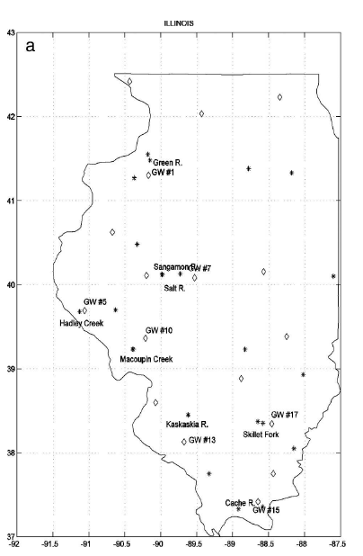
This methodology is powerful because it relies on limited assumptions in its reasoning. However the hypothesis in Equation (8) might be a weakness since at point scale it may not necessarily hold everywhere. The paper proposes this formulation based on fitting the long term observational data of groundwater level and streamflow in several sites in Illinois (see Figure 4 for details of these observation stations), implying that it's an empirical expression without physical derivation. The situation is that the relationship between local groundwater level and local subsurface flow may vary from hillslope area to riparian area. And this physically based variation may undermine the universal validity of Equation (6).
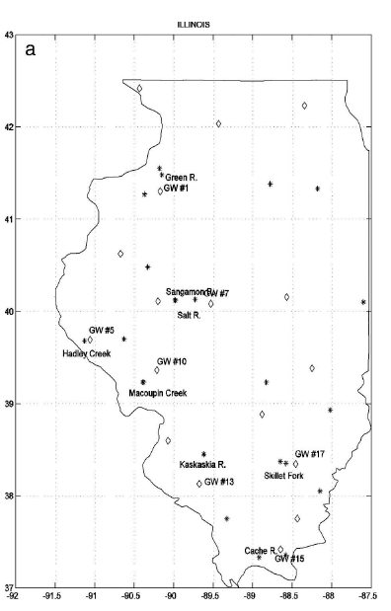

Figure 5 Observation stations used in Yeh & Eltahir’s paper to derive relationship between groundwater level and discharge, by Yeh & Eltahir

Another intellectual merit of this paper is that it fully utilize the mathematical properties of Gamma distribution as applied to simulating subgrid water table variation. When applying statistical method to LSM and simulation subgrid heterogeneity of variable of interest, the proper selection of distribution function is a essential step since the computational applicability would differ greatly for different versions of distribution function.

6. Suggestion of improvement on land surface hydrologic simulation in NCAR CLM
Based on previous analyses of these papers there are some suggestion about enhancing CLM’s capability of simulating and forecasting land surface hydrologic processes:
- In study areas where the spatial variation of soil hydraulic properties is very large, the subgrid representation of this variability may need to be incorporated into CLM, for example, the variability of top soil layer’s infiltration capacity;
- Integrating the moving boundary of water table level and lowest layer of soil reservoir is indispensable for accurately positioning the water table and calculating groundwater recharge; according to this consideration the simulating of water flux exchange at water table level need to be modified when the groundwater reservoir is in deep soil. Because at this circumstance the connection between CLM soil layer and saturated aquifer is weak and groundwater recharge can not be formulated as function of soil moisture and capillary potential in CLM’s lowest soil layer.
- Processes based simulation of groundwater discharge is desirable in order to make the CLM more robust. Specifically if a linkage between grid averaged discharge and grid averaged water table need to be generalized, it should be associated with physically based parameterization method.
Reference
(1) Impact factors in land-atmosphere interactions: surface runoff generations and interactions between surface and groundwater, Xu Liang, Zhenghui Xie, Global and Planetary Change, vol.38, 2003
(2) Groundwater influence on soil moisture and surface evaporation, Xi Chen, Qi Hu, Journal of Hydrology, vol. 297, 2004
(3), (4) Representation of Water Table Dynamics in a Land Surface Scheme. Pat J.-F Yeh and Elfatih A. B. Eltahir, Part I: Model Development; Journal of Climate, Vol. 18,No12, Part II: Subgrid Variability, Journal of Climate, Vol. 18, No 12. 2005
(5) Development of a Coupled Land Surface and Groundwater Model, Reed M. Maxwell and Norman L. Miller, Journal of Hydrometeorology, Vol.6, 2005

